Standard Operating Procedure
Step-by-Step Workflow Documentation

Step 1: Step 1
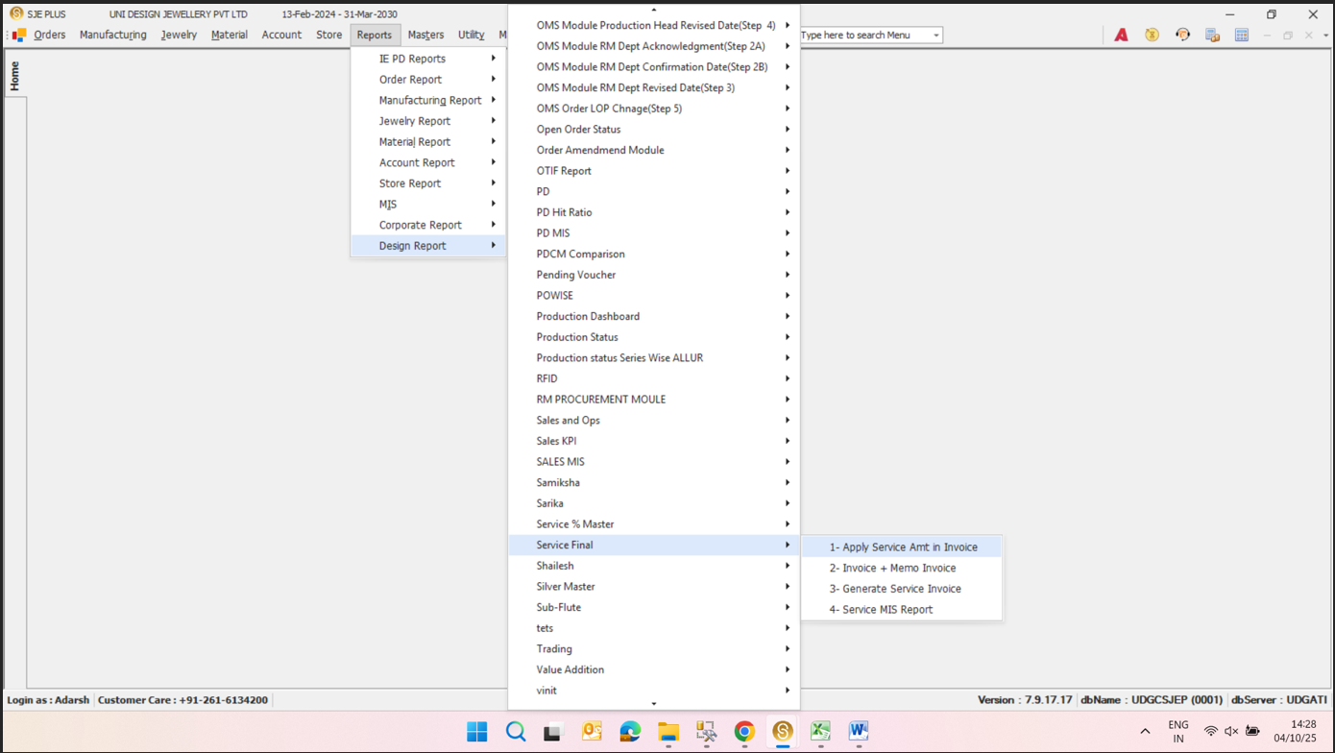
**Design Report**
Key objects & actions:
- **Design Report** —
- **1- Apply Service Amt in Invoice** —
- **2- Invoice + Memo Invoice** —
- **3- Generate Service Invoice** —
- **4- Service MIS Report** —

Step 2: Step 2
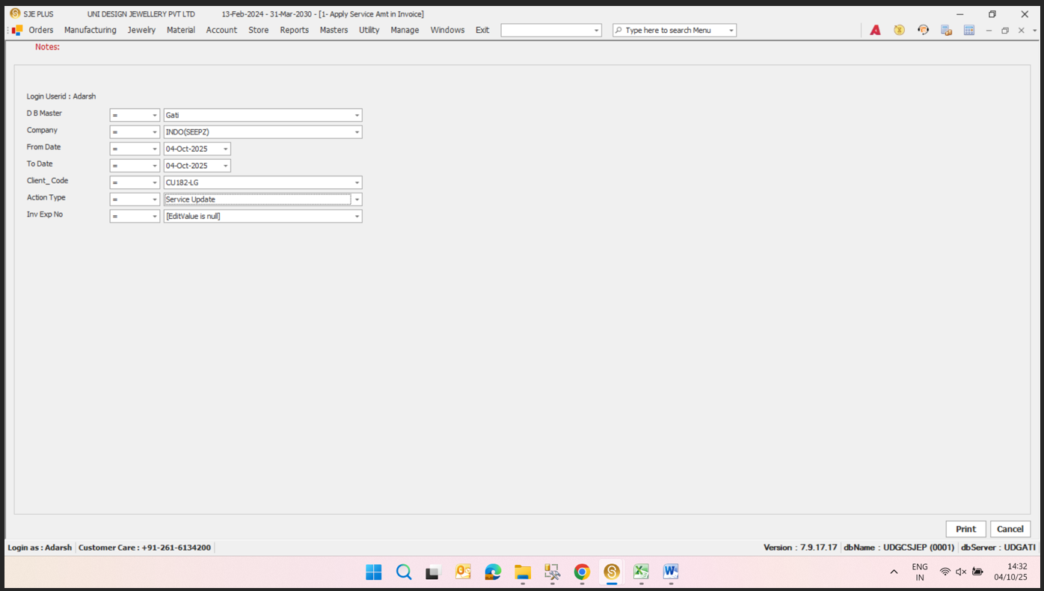
**Login**
Key objects & actions:
- **Login** — The user is logged in as "Adarsh."
- **Select Menu** — The user is navigating through the menu options, specifically under the "Orders" section.
- **Select Action** — The user is selecting an action type, which is currently set to "Service Update."
- **Input Date Range** — The user is entering a date range for the invoice, with the "From Date" set to "04-Oct-2025" and the "To Date" also set to "04-Oct-2025."
- **Client Code** — The user is entering a client code, which is "CU1824G."
- **Invoice Number** — The user is entering an invoice number, which is "null."

Step 3: Step 3
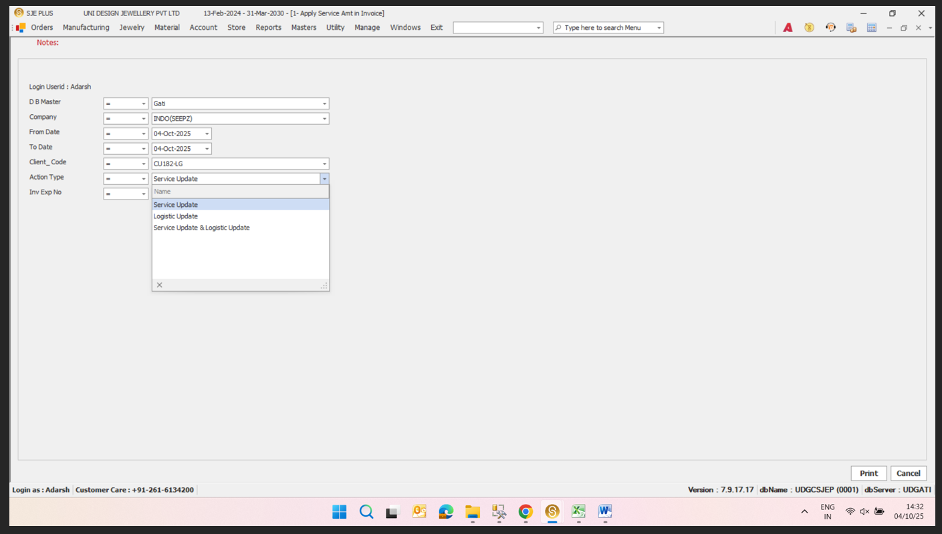
**Service Update**
Key objects & actions:
- **Service Update** —
- **Logistic Update** —
- **Service Update & Logistic Update** —

